**Max Thompson Website Report**

For my website, I initially struggled with coming up with an idea to base it around. After a lot of consideration, I decided to create a portfolio site for my photography work. I feel like this was the best choice for myself as I knew I would enjoy the process of creating the webpage based around, and I eventually was going to create a portfolio site so why not take advantage of the opportunity.

I started off by looking to an existing photography portfolio site for inspiration, my brothers’. He created the website several years ago for his final year at university to display his portfolio. As shown in the image below, he makes use of an image carousel. I felt like this was a good way to show off my images while also making use of a good amount of java script. I knew straight away that I would need to use java script for the switching between images and the buttons to do so. Also shown below is my initial design for my website, which I mostly stuck too.

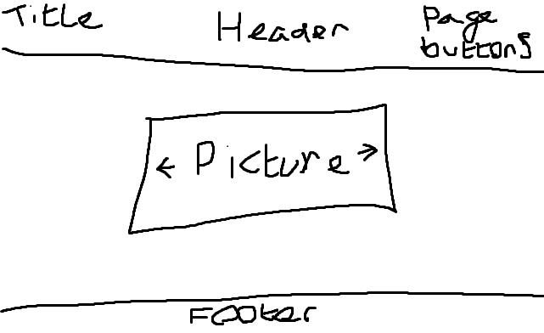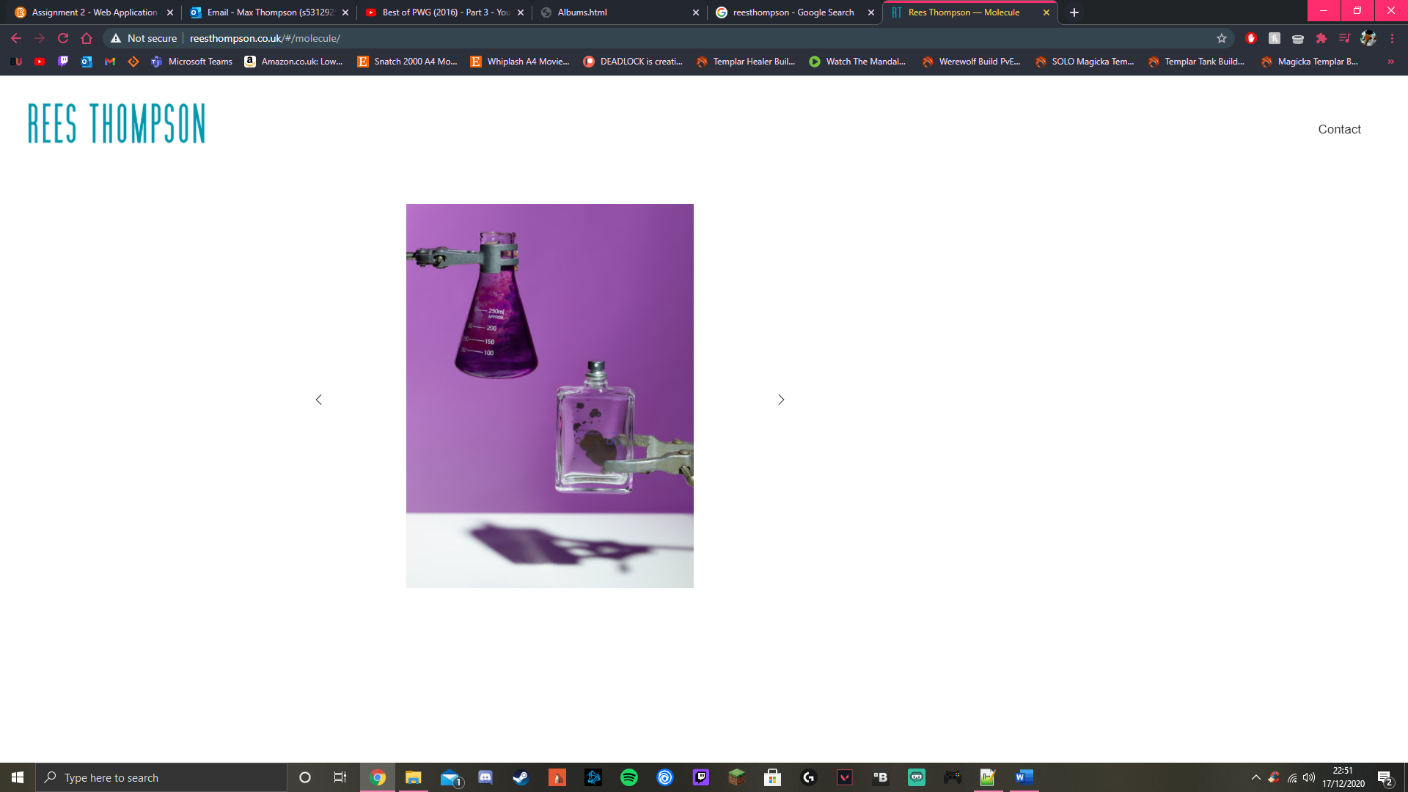

As I had never coded an image carousel in java script before, I referred to a youtube tutorial by Dev Ed. The tutorial was very effective and helped me greatly in understanding how java script functions within HTML coding. I did run into some hiccups however involving the images that I had chosen. At one point during the coding for the carousel, all my images would appear very stretched out for no reason. I finally resolved this issue by setting the minimum height and width of the images to 100%, forcing them not to stretch anymore. Then I added a basic looping function into the code, causing the images to be repeated if the user constantly clicks on the right arrow. This was as simple as setting the current image back to the first one in the list after the last one had been skipped. For the buttons used to traverse forwards and backwards in the image carousel, I downloaded an external CSS from font awesome. They have a range of pre-made buttons to use, which are easily referenced in a single line of code. One bug that I am still aware of is that if the user clicks either of the button’s multiple times very fast, the images fly off the screen and you are left with blank space. I will investigate this at a later date.

I then moved on to the header and footer that I would use throughout my entire website. The base idea I had for the header was very simple, the title of the website and some buttons hyperlinked to the other pages of the website. This was one of the most simple stages of the coding process as it was only a few lines of code in both the HTML and CSS sections. For the redirect buttons, I used the webpage W3Schools as a guide on how to implement them. I liked their form of header buttons the most as they detailed how to show the current pages button as active to the user, as well as when the cursor is hovering over the other buttons. It was as simple as adding sub-styles in the CSS to look out for when the cursor is over the button and change its colour accordingly. Shown below is the final product of my first page.

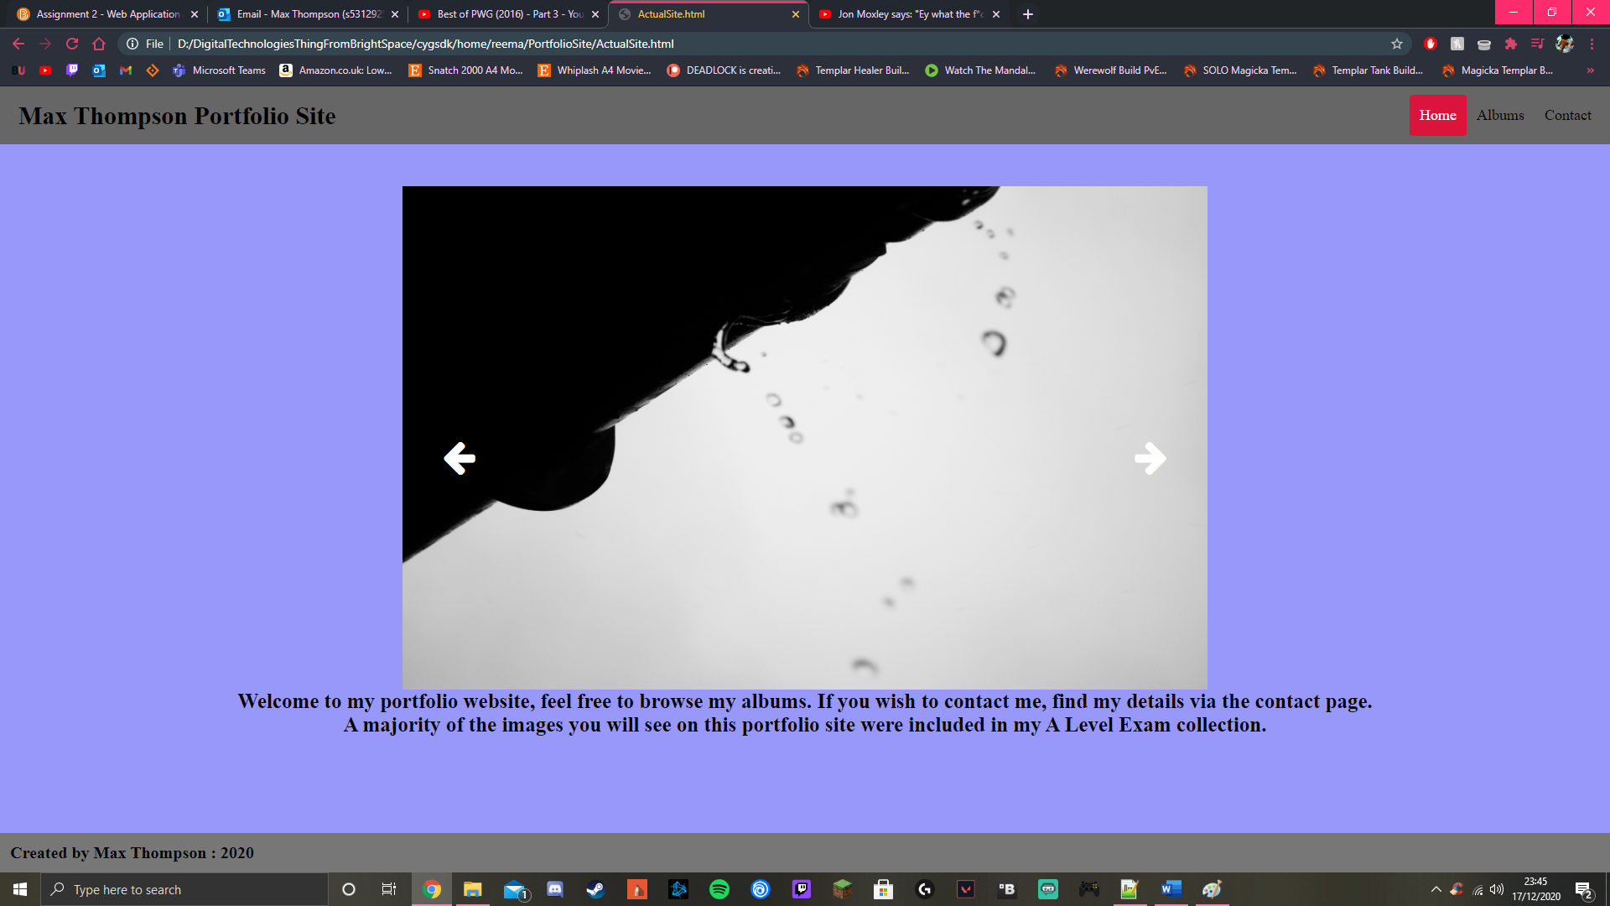

Next, I would make an album page in which the user can traverse to different albums by clicking on an image and being redirected to the correct page. This was very simple to do as all I had to do was start off the line of code that places the image onto the page with a href tag, much like my header buttons, allowing me to enter the correct page address. From there all I did was use the code I wrote earlier for the first carousel and edit it to use different images on the select pages.

Finally was the contacts page. My initial idea for this page was to allow the user to send me an email directly from the webpage. However, after some investigation I found that an external code source called php is needed to complete this process. I didn’t want to have to rely on additional addons to have a singular function work, so I decided to change it to a simple comment section that write s to a txt file in the websites folder. But yet again I ran into an issue with this idea. My lecturer Karsten pointed out to me that I would need to use an external server to process the writing to the file in this instance. The logic behind it makes perfect sense as the ability to write directly from the webpage to a txt file can be very insecure and could have major security issues down the line. I decided to accept defeat and instead go for a very simple popup to appear with my email included in it for the user. I also added a href link to my instagram page so the user can view even more of my work if they wish.

Overall, I found the coding of the webpage to go relativley smoothly after I had a large understanding of what I wanted to make. I ran into several bumps along the coding process, but time and research helped me overcome them and make me more omfortable with HTML coding as a result. There are definitly improvments that can be made on the wedsite, but that is something for another day.

**REFERENCING:**

W3Schools, year not specified. *HTML Layout Elements and Techniques* [online]. W3Schools. Avaliable from: <https://www.w3schools.com/html/html_layout.asp> [accessed 25th November 2020].

W3Schools, year not specified. *An image as a link* [online]. W3Schools. Avaliable from: <https://www.w3schools.com/tags/tryit.asp?filename=tryhtml_link_image> [accessed 27th November 2020].

W3Schools, year not specified. *How To – Responsive Header* [online]. W3Schools. Avaliable from: <https://www.w3schools.com/howto/howto_css_responsive_header.asp> [accessed 15th December 2020].

Dev Ed, 2018, *How to creat an image slider in HTML, CSS & Javascript* [online]. Youtube. Avaliable from: <https://www.youtube.com/watch?v=KcdBOoK3Pfw&t=1s&ab_channel=DevEd> [accessed 1st December 2020].

Rees Thompson, 2016.4 *Rees Thompson* [online].Self published by Rees Thompson. Avaliable from: <http://www.reesthompson.co.uk/> [accessed 18th December 2020].